**Anjali’s Cyber Tool: Password Strength Analyzer & Generator**

### 📅 **Internship Final Report**

**Name:** Anjali  
**Project:** Password Strength Analyzer & Wordlist Generator  
**Tools Used:** Python, Tkinter, Random Library  
**UI Style:** Pastel Gradient Aesthetic with Emojis & Custom Fonts

### ✨ **Abstract**

This project was developed as part of my cybersecurity internship. The main objective was to create a beginner-friendly, aesthetically pleasing password strength analyzer that can also generate secure passwords using user-specific keywords. The interface was customized to reflect a pastel, aesthetic theme inspired by feminine tech branding.

### 🌐 **Introduction**

Weak passwords remain one of the most common vulnerabilities exploited by hackers. Many users reuse personal details like names or birthdays, making them easy to guess. This project tackles that issue with a fun, creative UI that analyzes password strength, discourages predictable patterns, and helps generate stronger alternatives.

### ⚙️ **Steps Involved**

1. **Designed a split UI** with left and right panels using Tkinter.
2. **Left Panel**: User inputs for name, date of birth, email, and favorite fruit, band, flower (used for wordlist generation).
3. **Right Panel**: Password input, analysis result (remark), improved version of user’s password, and a newly generated strong password.
4. **Aesthetic Design**:
   * Soft pink pastel gradient using Canvas.
   * Bold title fonts (Lucida Calligraphy) and stylish inputs (Segoe UI).
   * Emojis used for icons and vibe ✨
5. **ENTER key navigation** to make the form smoother for new users.
6. **Analyzer logic** checks length, digits, and capital letters, and returns a strength remark.
7. Password suggestions are dynamically generated using random patterns.

### 🔹 **Screenshots**

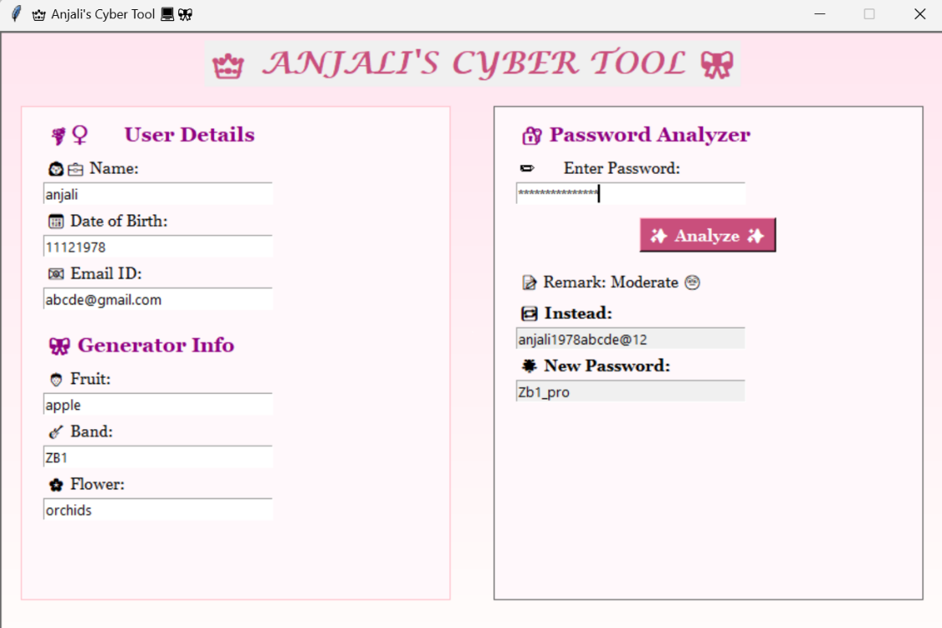

1. UI Overview
2. Password Strength Analysis in Action
3. Wordlist Generator Panel

### ✅ **Conclusion**

This project helped me understand user interface design in Python, password security logic, and how to create user-friendly applications. I also learned how to combine functionality and style. Through this tool, even beginners can understand password safety while enjoying a playful, accessible design.

### 🎓 **Skills Learned**

* GUI development using Tkinter
* Basic cybersecurity concepts (password analysis)
* Python functions and event bindings
* Creative UI design

### 📆 **Submission**

* Project Link:
* Date of Completion: *19/06/2025*